Program 1 – Print Details of Person:
Encapsulated class:
public class Task3_Person
{
private String name;
private int age;

public void Task3_Person(String name, int age)
{
this.name = name;
this.age = age;
}

public String getname()
{
return name;
}

public int getage()
{
return age;
}
}

Main Method:
public class Task3_Person_MainMethod {

public static void main(String[] args)
{
Task3_Person obj = new Task3_Person();
obj.Task3_Person("Nandhu", 28);
System.out.println("Name of the person is"+ " " + obj.getname());
System.out.println("Age of the person is"+ " " + obj.getage());

}

}

Output:
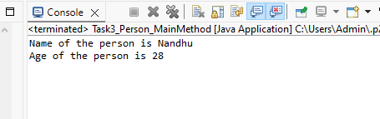

Program 2 – Printing Student details:

Encapsulated class:

package java_Task3_Programs;

public class Task3_Employee

{
private int id;
private String firstname;
private String lastname;
public int salary;
private int salary1;
public int percent;
public int revised_sal;
String Name;

public void setEmp(int id, String firstname, String lastname, int salary)
{
this.id = id;
this.firstname = firstname;
this.lastname = lastname;
this.salary = salary;
}

public int getID()
{
return id;
}

public String getFirstname()
{
return firstname;
}

public String getLastname()
{
return lastname;
}

public int getSalary()
{
return salary;
}

public String getName()
{
Name = firstname + " " + lastname;
return Name;
//System.out.println("Name of the Employee is" + " " + Name);
}

public void setSalary(int salary1)
{
this.salary1 = salary1;

}

public void getSalary1()

{
System.out.println("New Salary of the Employee : " + " " + salary1);
}

public int getAnnualSalary()
{
int AnnualSalary = (salary1 * 12);
return AnnualSalary;
}

public int raise_Salary(int percent)
{
revised_sal = (salary1 + (salary1 * percent)/100);
return revised_sal;
}

public String tostring()
{
return "Employee[id: " + id + "; Name: " + Name + "; Salary: " + revised_sal + "]";

}
}

Main Method:
public class Task3_Employee_MainMethod {

public static void main(String[] args)

{
Task3_Employee obj = new Task3_Employee();
obj.setEmp(001, "Aarthi", "Ravi", 10000);
System.out.println("Employee ID :" + " " + obj.getID());
System.out.println("Employee Firstname :" + " " + obj.getFirstname());
System.out.println("Employee Lastname :" + " " + obj.getLastname());
System.out.println("Employee salary :" + " " + obj.getSalary());
System.out.println("Full Name of the employee :" + " " + obj.getName());
//obj.getName();
obj.setSalary(20000);
obj.getSalary1();
System.out.println("Annal Salary of an Employee :" + " " + obj.getAnnualSalary());
//obj.raise_Salary(30);
System.out.println("The revised salary :" + " " + obj.raise_Salary(30));
System.out.println();
System.out.println(obj.tostring());

}

}

OUTPUT:
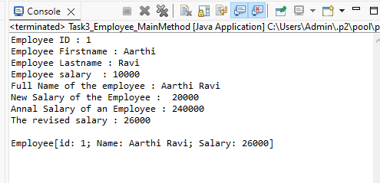

Program 3 – Calculate Circumference of Circle

package java_Task3_Programs;

public class Circle {

double rad;
final double PI = Math.PI;
double C;

public double Circle()
{
rad = 1.0;
return rad;
}

public double Circle(int rad, double PI)
{
this.rad = rad;
return rad;
}

public double Circumference_Of_Circle()
{
C = 2*PI*rad;
return C;
}
public static void main(String[] args)

{
Circle obj = new Circle();
System.out.println("Constructor with no arguements - Radius is "+ obj.Circle());
System.out.println("Constructor with two arguements - Another Radius is "+ obj.Circle(9,0));
System.out.println("Circumference of the circle is : "+ obj.Circumference_Of_Circle());

}

}

OUTPUT:
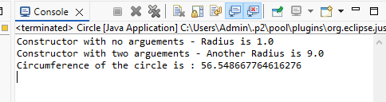

Program 4 – Create Account Class

package java_Task3_Programs;

public class Task3_Account_class
{
private String Cust_name;
private int acc_num;
private double balance;
public double withdraw;
public double deposit;

public void Task3_Account_class()
{
this.Cust_name = "xxx";
this.acc_num = 0;
this.balance = 0.0;
System.out.println("CUSTOMER DETAILS ARE GIVEN BELOW");
}

public void Task3_Account_class(String Cust_name, int acc_num)
{
this.Cust_name = Cust_name;
this.acc_num = acc_num;
this.balance = 1000.0;
System.out.println("Initial balance is " + " " + balance);
}

public void deposit(int deposit)
{
System.out.println("Deposit amount is" + " " + deposit);
this.balance = balance + deposit;
}

public void withdraw(int withdraw)
{
if(withdraw <= balance)
{
System.out.println("Sufficient balance to withdraw the given amount");
}
else
{
System.out.println("In-Sufficient balance to withdraw the given amount");
}
}

public void Checkbalance()
{
System.out.println("Check balance of Customer account is" + " " + balance);
}

public static void main(String[] args)
{

Task3_Account_class obj = new Task3_Account_class(); // Constructor with no arguments (giving invalid details)
obj.Task3_Account_class("Anitha",2345); // Constructor with two arguments (giving valid input)
obj.deposit(4000);
obj.withdraw(4000);
obj.Checkbalance();

}

}

Output:
